Maximum Sum Combination
Problem Statement: Given two integer arrays nums1 and nums2 and an integer k, return the maximum k valid sum combinations from all possible sum combinations using the elements of nums1 and nums2. A valid sum combination is made by adding one element from nums1 and one element from nums2. Return the answer in non-increasing order.
Examples
Input : nums1 = [7, 3], nums2 = [1, 6], k = 2
Output : [13, 9]
Explanation : The 2 maximum combinations are made by: nums1[0] + nums2[1] = 13 nums1[1] + nums2[1] = 9
Algorithm
Instead of generating all combinations, we can only focus on the largest possible sums using a Max Heap. We begin with the sum of the largest elements in both arrays and then explore their neighboring sums using indices. To prevent duplicate work, we use a set to keep track of which index pairs we've already added to the heap. This method simulates a best-first search where we always explore the next largest unexplored sum.
- Sort both input arrays in descending order.
- Use a max heap to store tuples of (sum, index1, index2).
- Push the initial max sum formed by the first elements of both arrays into the heap.
- Maintain a set to track visited index pairs.
- Repeat the following k times:
  - Pop the current largest sum from the heap.
  - Add it to the result.
  - Push the next two possible combinations (moving one index forward in either array) into the heap if not visited.
- Return the result list after collecting k sums.
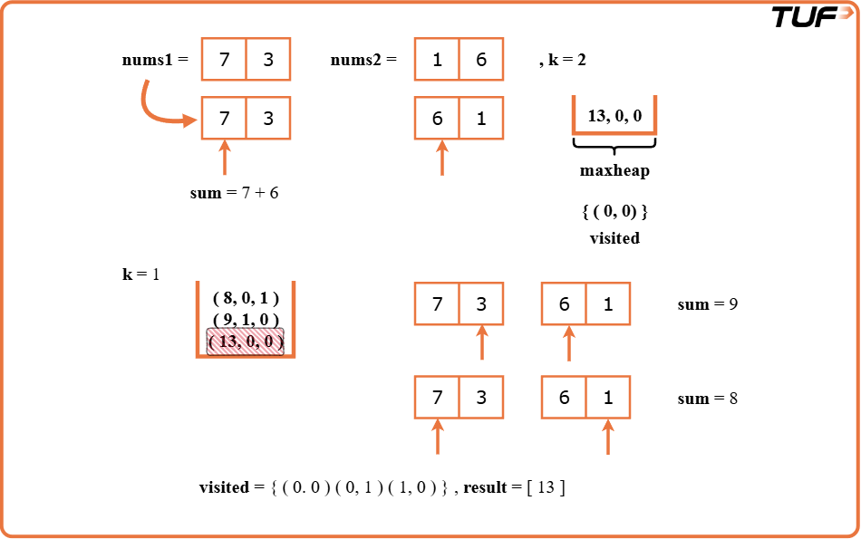
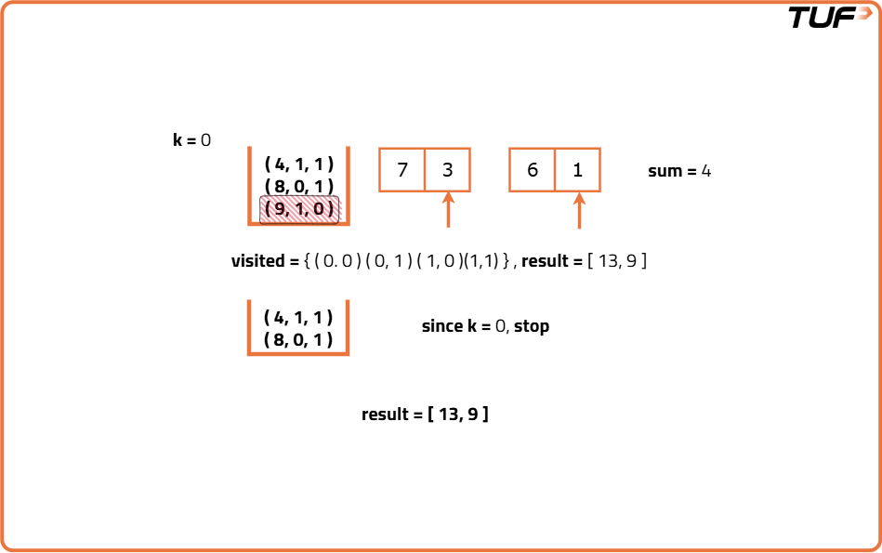
Code
import java.util.*;

// Class that implements the solution
class Solution {
// Function to find k maximum sum combinations
public List<Integer> maxCombinations(int[] nums1, int[] nums2, int k) {
// Sort both arrays in descending order
Arrays.sort(nums1);
Arrays.sort(nums2);
int n = nums1.length;

// Max heap to store sums and their indices
PriorityQueue<int[]> maxHeap = new PriorityQueue<>((a, b) -> b[0] - a[0]);

// Set to keep track of visited index pairs
Set<String> visited = new HashSet<>();

// Push initial max sum combination
maxHeap.offer(new int[]{nums1[n - 1] + nums2[n - 1], n - 1, n - 1});
visited.add((n - 1) + "," + (n - 1));

// Result list
List<Integer> result = new ArrayList<>();

// Extract top k combinations
while (k-- > 0 && !maxHeap.isEmpty()) {
int[] current = maxHeap.poll();
int sum = current[0], i = current[1], j = current[2];

result.add(sum);

// Check for new combination (i - 1, j)
if (i - 1 >= 0) {
String key1 = (i - 1) + "," + j;
if (!visited.contains(key1)) {
maxHeap.offer(new int[]{nums1[i - 1] + nums2[j], i - 1, j});
visited.add(key1);
}
}

// Check for new combination (i, j - 1)
if (j - 1 >= 0) {
String key2 = i + "," + (j - 1);
if (!visited.contains(key2)) {
maxHeap.offer(new int[]{nums1[i] + nums2[j - 1], i, j - 1});
visited.add(key2);
}
}
}

return result;
}
}
Time Complexity: O(k * log k),The loop runs k times, and in each iteration, we perform heap insertions and deletions, which cost O(log k). In total, this results in O(k log k) time.
Space Complexity: O(k), The heap and visited set can grow to size k in the worst case.

